Name: Period:
Absolute Location Notes
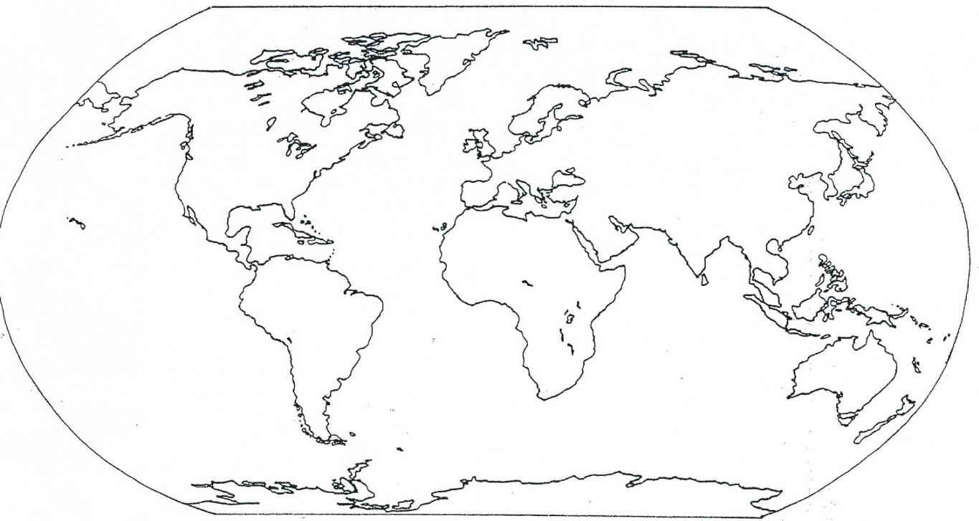
Absolute Location: the location of a place using latitude (North/South) and longitude (East West) coordinates.
Example: 120°N, 35°E
34°S, 95°W
Whenever we write absolute location, we write North/South first, because we always describe locations
using North/South first. For example, we you don’t say East-North Ohio or West-North street.

Relative Location: the location of a place in relation to another place Example: Columbus is 32 miles west of Newark
Australia is Southeast of Asia

Equator: the line of latitude that separates the Northern and Southern Hemisphere

Prime Meridian: the line of longitude that separates the Eastern and Western Hemisphere

Write each letter’s absolute location
A | 75°N, 90°W |  | E
B |  |  | F
C |  |  | G
D |  |  | H

Write each city’s absolute location
Cairo | 23°N, 25°E |  | Cape Town
Dallas |  |  | Rio De Janeriro

Name: Period:
Absolute Location Notes
Absolute Location: the location of a place using (North/South)
and (East West) coordinates
Example: 120°N, 35°E
34°S, 95°W
Whenever we write absolute location, we write North/South first, because we always describe locations
using North/South first. For example, we you don’t say East-North Ohio or West-North street.

Relative Location: the of a place in to another place Example: Columbus is 32 miles west of Newark
Australia is Southeast of Asia

Equator: the line of that separates the Northern and Southern Hemisphere

Prime Meridian: the line of that separates the Eastern and Western Hemisphere

Name: Period:
Absolute Location Notes
Absolute Location:

Example: 120°N, 35°E
34°S, 95°W
Whenever we write absolute location, we write North/South first, because we always describe locations
using North/South first. For example, we you don’t say East-North Ohio or West-North street.

Relative Location:

Example: Columbus is 32 miles west of Newark
Australia is Southeast of Asia

Equator:

Prime Meridian:

