Globes and Geographic Tools
Main ideas of this content statement
Maps are drawings that represent a portion of the Earth’s surface on a flat piece of paper that can be folded and transported easily. A map is a "snapshot” showing geographic information. We use maps to find our way from one place to another, to see where places are located, or to show how far one place is from another. To grasp the information on the map, you need to understand its different parts.
Key or Legend
A key or legend on a map explains what each symbol on the map represents. This map of Australia uses four symbols.
The star symbol shows the location of Australia’s capital city. Each large dot shows the location of a major city in Australia. The triangle symbol is used to show the location of Australia's mountains. The shaded area with lots of dots shows the location of Australia's deserts.

Scale
It would be ridiculous if the map of an area were full-size. A full-sized map would be too large to read and would serve no useful purpose. For this reason, every map is smaller than the area it represents. A map uses a scale to show how much it has been reduced from the area it represents. The scale tells what each distance on the map represents in real life. For example, 1 inch on the map may represent 100 miles in real life. If two cities on that map are 3 inches apart, then the actual distance between them is 300 miles.

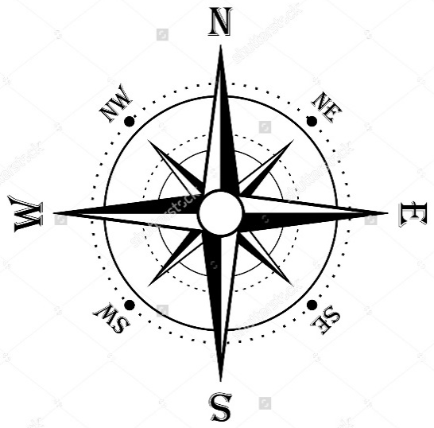
Compass Rose
A compass rose shows where each of the cardinal directions (North, South, East, West) are. Sometimes the compass rose also shows the intermediate directions (NE, NW, SE, SW).

Finding Specific Information
If you wanted to find which city in Australia is closest to the great Victoria desert:
- You would first need to locate the Great Victoria desert on the map. It is found in the southwest area of Australia.
- Next, you can see that Menzies is the closest city to the great Victoria desert.

Now that you have learned how to find and interpret information on a map,
let's see how well you can apply the scale.
1.) Based on the map, what is Australia’s capital city? _____________________  2.) Based on the map, which two cities are less than 250 miles apart?  - Menzies and Alice Springs  - Canberra in Melbourne  - Darwin and LaGrange  - Brisbane and Sydney | 3.) Which statement is most accurate about Australia? (accurate means correct)  - Most of Australia's land is made up of mountains.  - All mountain areas are located along the East Coast.  - Australia is a country surrounded by water.  - The largest city in Australia is Darwin.

Different types of maps
Cartographers, or map makers, use a variety of different types of maps. Each type of map serves a specific purpose. Learning to recognize the different types of maps is an important skill, helping you to know what can be learned from each map.
- Political maps are concerned with governmental boundaries. They show the boundaries and locations of countries, states, in major cities. Sometimes, a political map will also show capitals in the location of major towns in countries. These maps are extremely colorful the majority (most of) the time.
- Physical maps display the geographic features of an area. They usually show the physical features, such as oceans, seas, islands, mountains, lakes, rivers, deserts, and forests.
- Topographical maps are a type of physical map. In addition to showing landforms, they often show elevations – how high a places above sea level.
- Climate maps show the average monthly or annual (yearly) weather conditions. They provide temperatures, rainfall, and snow amounts of an area.
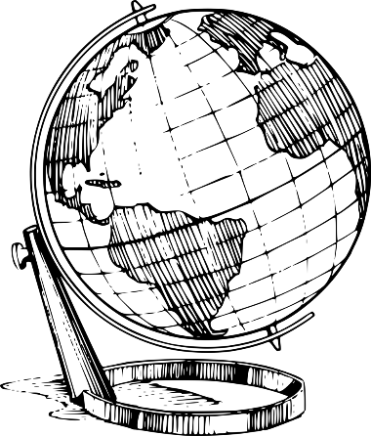
- Population density maps show how many people live in an area relative to the space occupied by them. For example, an area may have 50 people per square mile. That means the population is denser (or more dense) than an area that may only have 15 people per square mile. Often times people have a higher standard of living (a better place to live) if their country isn’t over-crowed.
- Product maps show the natural resources as well as different products that are made in a particular area.
- A globe is much different than a map in several ways. It is a round three-dimensional representation of earth. A globe is there for a better model of earth than a flat map since the earth itself is a sphere, like a ball. Because it is round, a globe can represent long-distance is more accurately than a flat map. Globes help us to see where places are located on earth, as well as make it easier to compare the sizes of continents to one another. However, they are much more difficult to carry around then maps.

Other geographic tools
Cartographers have several geographic tools they use to gather and analyze information in order to make maps.
- Aerial photographs are photographs of the land that are taken from a helicopter, airplane, or satellite. The greater height makes it easier to see the main features of a place.
- Digital satellite images are made from images taken by satellites in outer space. These photographs are then put together by computers to make a digital image. Google maps makes use of satellite images. Search images can offer a great deal of information about a place. For example, this nighttime satellite image of north and South Korea clearly reveals the lack of electric power to North Korea.
- Historical maps are maps from the past. They can be used by cartographers to create their own maps showing how a place looked in the past. To the right is a map of Phoenicia and the Hebrew Kingdoms as they might have looked 3000 years ago.

