Latitude and Longitude Worksheet II
Use the map to answer the following questions about latitude and longitude.
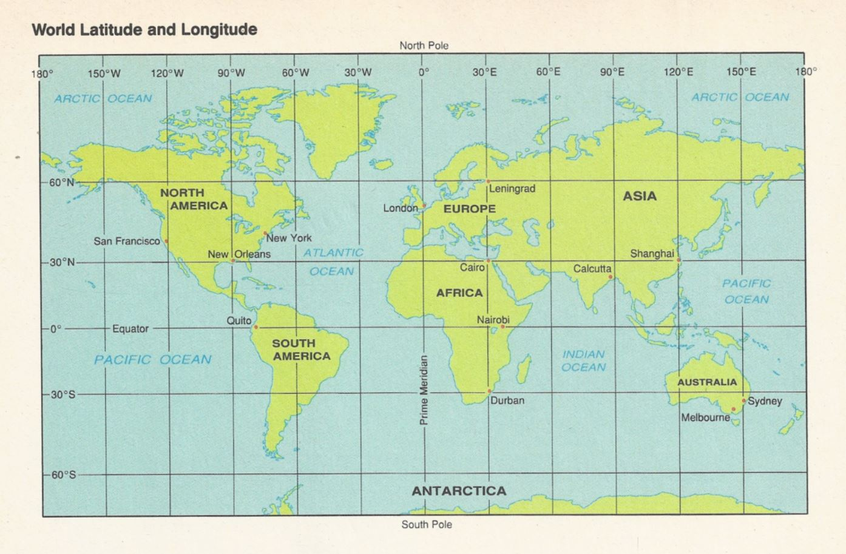

- On what continent would you find each of the following locations?
  - 15°S, 50°W _________________________
  - 45°N, 15°E _________________________
  - 35°N, 0° ___________________________

- In what ocean would you find each of the following location?
  - 80°N, 150°W _________________________
  - 20°S, 85°E __________________________
  - 0°, 90°W ____________________________

- Give the coordinates for each city.
  - Sydney _____________________________
  - San Francisco ________________________
  - Nairobi _____________________________

