Name: Period:
Working with a Map: Brazil

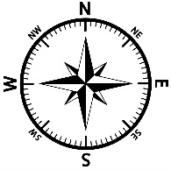

1.) What is the Capital City of Brazil?

2.) Use your pencil to shade in Bolivia.

3.) Brazil borders the South Pacific Ocean.
a. True
b. False

4.) About how many miles is it from Porto Alegre to Curitiba?
________________________

5.) Which of the following countries does not border Brazil?
a. Argentina
b. Chile
c. Columbia
d. Paraguay
e. Peru

6.) Which of the following cities is closest to Peru?
a. Campo Grande
b. Sao Paulo
c. Rio Branco
d. Boa Vista

7.) Which of the following cities is southwest of Rio de Janeiro?
a. Manaus
b. Viloria
c. Sao Luis
d. Curitiba

8.) If you were traveling from Guyna (GUY) and going northeast, which of the countries would you most likely pass through?
a. Peru
b. Suriname (SUR)
c. Brazil
d. Argentina

