Government Types
directions: In the circles below, there are elements related to each governmental type. Color them with the appropriate color
Democracy  Blue |  | Dictatorship  Red |  | Monarchy  Green |  | Theocracy  Orange
Inherits power
Religious leader rules government
Personal
Rights
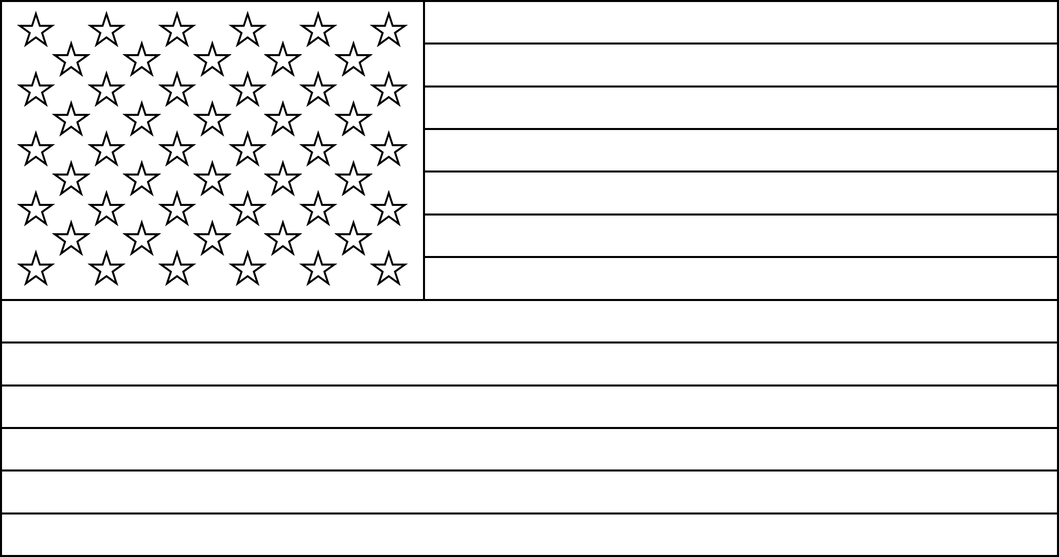
Divine
King
Power by Force
Elected
Civil Liberties
Religion
Religious Police
President
Military Ruler
One family rules for generations
For the people, by the people

